Overview
HHMI Tangled Bank Studios and STAR Net invite you to join us in celebrating 250 years of science in the United States through an educational suite of free materials with Science Across America, the second campaign in the Spark of Science@ My Library initiative that focuses on the past, present, and future of science in the United States of America.

Since its founding, the United States has been a leader in scientific discovery; exploring questions in fields as diverse as biology, physics, medicine and more. Science has resulted in breakthroughs that positively affect our lives in innumerable ways. From the light bulb to the Human Genome Project to the invention of GPS, science has driven us forward, and discoveries have been made by teams from every corner of the country. Science Across America gives us the chance to celebrate both the globally game-changing discoveries themselves, and the local researchers who may be toiling on the latest breakthroughs right up the street.

To shine a light on American scientific innovation, participating libraries will create events and activities that feature the past, present and future of scientific innovation in their communities, counties, and states. Using a robust suite of customizable activities and materials, they’ll help their patrons explore how science gets done, what impact it has, and how they can see themselves in their scientist neighbors.

Please complete the below application to be eligible for the following:

Resources
Selected libraries will receive:

- $500 honorarium to help cover the cost of events and program outreach
- A printed “StoryWall” poster to document your community’s science story
- Informal Activity Guides – Created by STAR Net including curated materials related to basic science areas
- How-To Guide for hosting Science-Centered Community Dialogues
- Support from STAR Net staff to host your own Community Dialogues
- Promotional Materials (digital) to publicize your events
- Digital Copies of Wild Hope episodes:
- Access to virtual programs hosted by Exploring by the Seat of Your Pants
Project Director and Shipping Information
Note: The Project Director is the person who will be responsible for coordinating the activities and programs at the library or other partner sites. They will be the primary point of contact for the project at the applicant institution. All fields are required unless noted otherwise.
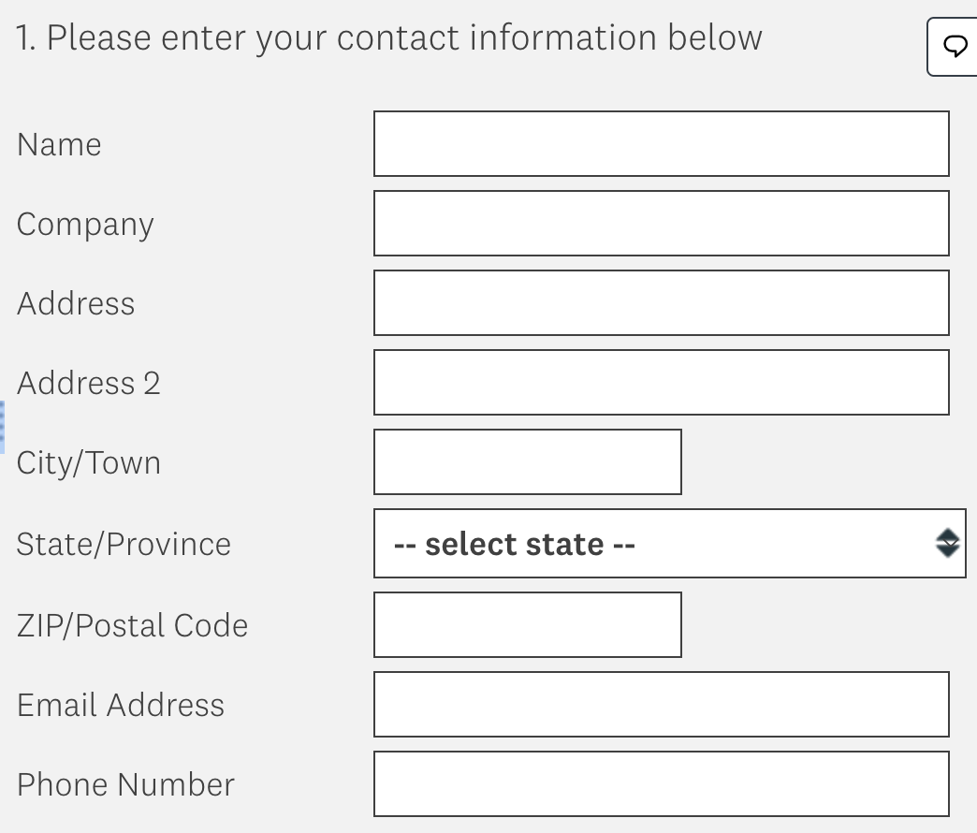
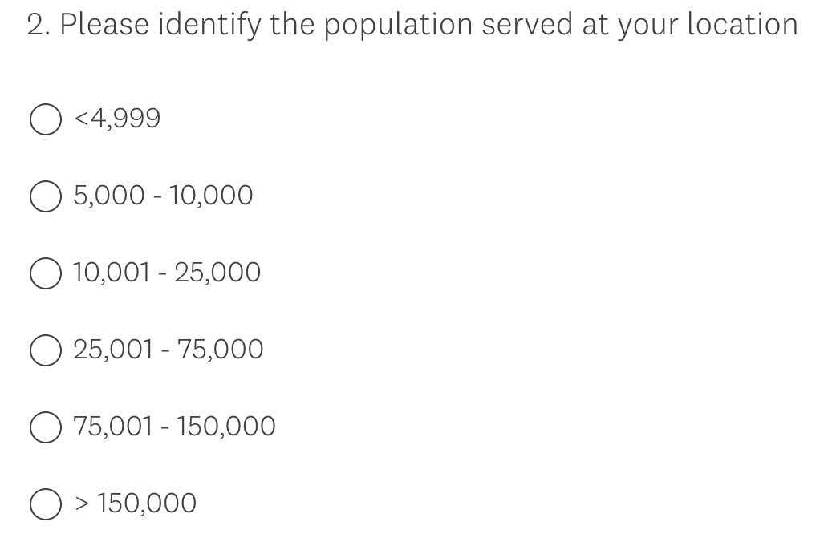
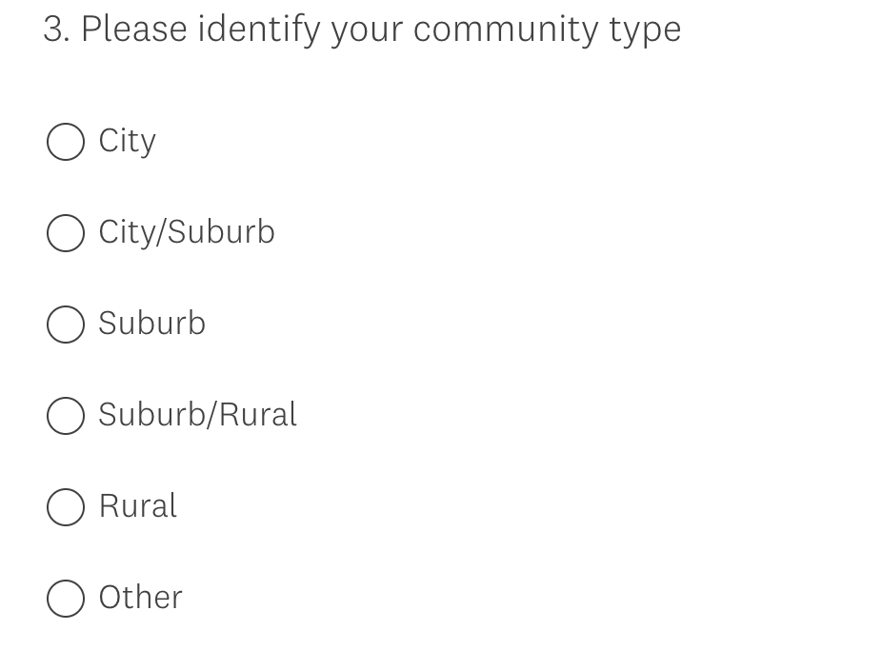

Proposal Narrative
Please write a narrative describing your plans for presenting this program and accompanying programs. The proposal narrative consists of seven sections (described immediately below). Please note that each section of the narrative may not exceed 400 words.
Q4. Describe why your library would like to participate in this project, including community interests in STEAM topics, demographics, collections, or other resources or programming focus areas related to natural and materials sciences (especially those related to science happening in your own community). What are your prior experiences with offering public programs about STEAM topics? Or about topics specifically related to the history of science?

Q5. Please describe who from the library (including staff and volunteers) will support this project. Provide detailed information about their experience and planned role on the project. CVs/resumes are not required.

Q6. Community Dialogues are a required component of participation in this program. While past experience conducting these Dialogues is not required, we'd like to hear how you've gathered feedback from patrons in the past, so we can better incorporate these methods of feedback gathering into our Community Dialogue plans. Participating libraries will receive extensive training and support related to conducting these community conversations. In addition to learning more about how you've gathered feedback in the past, we'd also love to hear what you'd like to focus on in your required Community Dialogue. Building partnerships? Identifying local science? Learning more about the history of science in your community? Whatever interests you!
To learn more about Community Dialogues, either to incorporate them into this project or to your libraries future plans, please visit https://www.starnetlibraries.org/deia/community-dialogues/

Q7. A major focus of the Science Across America project is to reach underserved audiences with STEAM programming. Identify at least one principal underserved audience you will reach with programming for this exhibition and make a strong case for why you have chosen this audience and how you will reach them. Please reference Census or other data in making your case. A generally underserved geographic area can be considered an underserved audience. Please note that the intent of this requirement is for you to reach new audiences or to increase reach to those audiences. Successful applicants will demonstrate plans to increase participation of their underserved audience, not merely state that they use the venue currently.

Q8. Collaboration with STEAM organizations and individuals with STEAM expertise is very important to the success of this project, as are partnerships with community organizations that do not focus on STEAM. Please tell us what partnerships with STEAM (4H, astronomy clubs, museums, rockhounds) and community organizations (like cultural institutions, schools, churches, etc) and individuals in your community/region will help you to make your programs a success. Have you worked with these organizations/individuals before? If you’d like to partner with a new organization, what are your plans for building that partnership? Please reference BOTH types of organizations (STEAM organizations and community organizations) in your response. A letter of commitment is not required, but we do request that you confirm interest in participation with the venue, rather than sharing possible partners.

Q9. Describe the programs you plan to implement to meet or to exceed the project requirements. Project requirements are: 2 programs for public audiences of any age. We realize your program plans may change after award, so you are not obligated to these plans. Please describe potential plans for these programs. Remember, programs can be done in collaboration with your current or future partners!

Q10. Describe your general publicity plans for promoting your events and community engagement. How will your partnerships organizations described above aid in promotion?

